1. Which are the top three variables in your model which contribute most towards the probability of a lead getting converted?

Ans: To identify the top three variables, we would look at the coefficients from the logistic regression model. The features that most influence on the probability of lead conversion are:

1. Lead Origin
2. Lead Source
3. Total Time Spent on Website.

The below image shows the feature details in descending order:

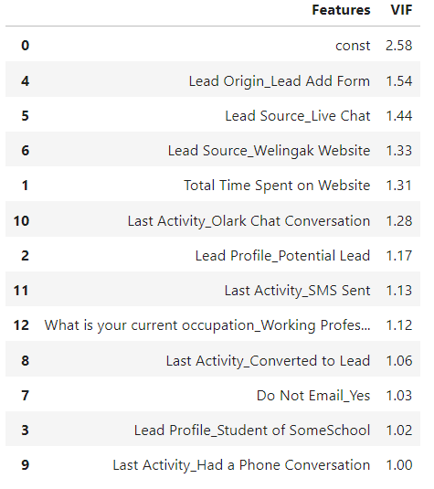

1. What are the top 3 categorical/dummy variables in the model which should be focused the most on in order to increase the probability of lead conversion?

Ans: Categorical or dummy variables with the most significant impact based on their coefficients could be:

1. Lead Origin_Lead Add Form
2. Lead Source_Live Chat
3. Lead Source_Welingak Website
4. X Education has a period of 2 months every year during which they hire some interns. The sales team, in particular, has around 10 interns allotted to them. So during this phase, they wish to make the lead conversion more aggressive. So they want almost all of the potential leads (i.e. the customers who have been predicted as 1 by the model) to be converted and hence, want to make phone calls to as much of such people as possible. Suggest a good strategy they should employ at this stage.

Ans: During this phase, to maximize conversions, X Education should:

* Target leads who obtained their information from references, as they are more likely to convert
* Target leads who visit the website on a regular basis (Page Views Per Visit). Nonetheless, the frequency of visits may indicate that consumers are returning to compare courses from the other sites. In order to ensure that competitive elements where X-Education is superior are strictly underlined, the interns should be a little more assertive.
* You should focus on prospecting leads from your important visitors who stay on a specific X-Education sub-domain for an extended period of time.
* Although students can be contacted, because the course is industry-based, their conversion rate will be lower. But this can also serve as a driving force to make sure they're prepared for the workforce by the time they finish their education.

1. Similarly, at times, the company reaches its target for a quarter before the deadline. During this time, the company wants the sales team to focus on some new work as well. So during this time, the company’s aim is to not make phone calls unless it’s extremely necessary, i.e. they want to minimize the rate of useless phone calls. Suggest a strategy they should employ at this stage.

Ans: X education can reduce the calls by:

1. Please don't concentrate on the students because they are already enrolled in classes and won't be willing to take one early in the term that is intended specifically for working professionals.
2. Avoid concentrating on jobless leads. It's possible that they don't have sufficient funds for the course.
3. Email First Approach: Prioritize email follow-ups before making calls to assess interest. Only if a lead responds positively or shows engagement
4. Increased lead score cutoff: During this time, cut off can be increased. For example contact the customers with lead score above 95.